PERSONAL PORTABELLa Lasagna
Serves 4

INGREDIENTS
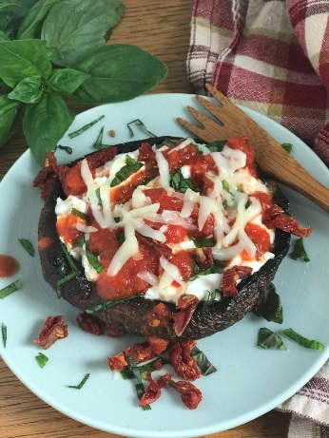
- 4 large Portabella mushroom caps
- 4 Tbls. olive oil
- ¼ cup cottage cheese
- ¼ cup part-skim ricotta cheese
- 1 clove garlic, minced
- 4 Tbls. chopped fresh basil
- ½ cup sun-dried tomatoes
- 4 Tbls.+ tomato sauce
- ½ cup mozzarella
- Fresh ground pepper

INSTRUCTIONS
- Brush both sides of the mushroom caps with olive oil.
- Spray large skillet and heat over medium heat. Sear mushrooms on both sides until most of the moisture has evaporated (4-5 minutes per side).Remove mushrooms from skillet and place on a plate.
- Mix cottage, ricotta cheese and garlic in a bowl. Fill mushroom caps with cheese mixture, topping with basil, sun-dried tomatoes, sauce, mozzarella and pepper, dividing all ingredients evenly between the 4 caps.
- Broil for 1-2 minutes until cheese melts and serve.

Recipe from: www.judymatusky.com

