Mini meatloaves
Serves 18

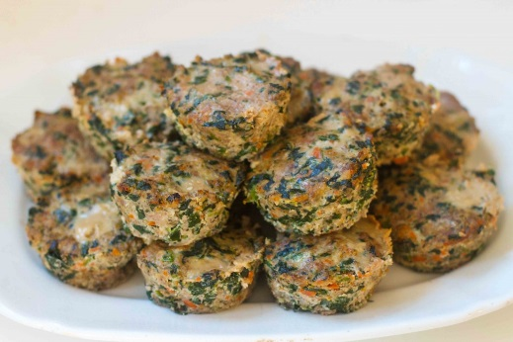
INGREDIENTS

- 2lbs lean ground beef or turkey
- 10oz frozen spinach, thawed
- 1-2 tsp. olive oi
- 1.5 cups Mirapoix (or other mix of chopped veggies-mushrooms are delicious!)
- 4 eggs, beaten
- 1/3 cup coconut flour
- 2 tsp. each salt & pepper
- 1-2 Tbls. Italian seasoning

INSTRUCTIONS
- Heat oven to 375.
- Squeeze water out of frozen spinach. Heat oil in a pan and cook all veggies together until soft.
- Mix meat, veggies and all other ingredients in a bowl with your hands.
- Fill 18 greased muffin tin spots to the top with mixture. Cook 20-25 minutes.

Yummy with marinara sauce on top, served with mashed cauliflower or chopped into a salad.

Recipe adapted from www.paleospirit.com

